Conda Lab 01: Getting Started: Hands-on Setup and Developing Python Environment for Coding

Installation and Setup
- Install Python v3.9 from Python Downloads. Select a downloadable file based on your operating system. Use custom installation (install it in C:\Python39) and mark "Add to PATH."
- Install the stable build of VSCode from Visual Studio Code.
- In VSCode, press Ctrl + Shift + X to open the Extensions tab (Cmd + Shift + X on Mac).
- Install the Jupyter extension (released by Microsoft). The one you select should have around 94M downloads.
- Install the Python extension (released by Microsoft). The one you select should have over 180M downloads.
- Go to View -> Command Palette (or use Ctrl + Shift + P).
- Start typing Python: Select Interpreter.
- Choose the Python interpreter ending in C:\Python39\python.exe. (If you already have another Python version installed, you may stick with that.)
- Go to View -> Command Palette, then type Jupyter. You will be given an option to create a new blank notebook.
- Enter print("Hello, World!") and run it to test your installation (Ctrl + Alt + Enter).
- You are now done with the software installation. Next, we need to create an environment to run code. Use python3 -m venv my_project in the project directory. Alternatively, you can use a conda environment (conda create --name my_project).
- Activating the virtual environment )(Mac: source my_project/bin/activate, windows: my_project\Scripts\activate).
- Hint for Windows’ users, sometimes when you are activating the virtual environment, you just created (my_project), you might get the following security error:
Activate.ps1 cannot be loaded because running scripts is disabled on this system. For more information, see about_ Execution_Policies at https:/go.microsoft.com/fwlink/?LinkID=135170.
At line:1 char:1
+ my_project\Scripts\activate
+ NANNNANNUN
+ CategoryInfo
: SecurityError: (:) [], PSSecurityException
+ FullyQualifiedErrorId
: UnauthorizedAccess
- Run this to fix it:
Set-ExecutionPolicy -Scope CurrentUser -ExecutionPolicy RemoteSigned
- Then try to activate your virtual environment: \my_ project\Scripts\Activate
- Open a terminal in VSCode from View -> Terminal or use `Ctrl + ``.
- Navigate to the directory where you have the Python interpreter (python.exe). (See page 2 for navigation tips in the terminal.)
- Run this command: py -m pip install numpy.
- Run the same command, replacing numpy with pandas, matplotlib, and sklearn.
- If you get an error for “pip install sklearn”, try “pip install scikit-learn”
- You can also install packages in Jupyter Notebook using !pip install matplotlib.
- To Test matplotlib:
- Run: python
- Copy the following code:
import matplotlib.pyplot as plt
import numpy as np
plt.plot(np.random.randn(5))
plt.show()
For additional information, see VSCode Jupyter Notebooks Documentation.

Description of the Command MacOS/LINUX Windows

Action | macOS/Linux Command | Windows Command
Navigating Directories
List Contents | ls | dir
List Open Files | lsof | N/A
Change Directory | cd directory_name | cd directory_name
Print Current Path | pwd | cd
Save and Move | pushd / popd | N/A
Modify Files and Directories
Create Directory | mkdir directory_name | mkdir directory_name
Remove Directory | rmdir directory_name | rmdir directory_name
Move/Rename | mv source destination | move source destination
Copy | cp source destination | copy source destination
Remove File/Directory | rm file_name | del file_name
View Files
Page Through | less file_name | more file_name
Display Content | cat file_name | type file_name
Create Empty File | touch file_name | echo. > file_name
Search Files and Content | find dir -name filename | dir /s filename / findstr
Authority and Help
Superuser Access | sudo | runas
Read Manual | man command_name | help command_name
Network Information | hostname | hostname
Change Permissions | chmod | N/A
Change Ownership | chown | N/A
Download Files | wget | wget
Terminate Tasks | kill | taskkill
Check Jobs | jobs | N/A
Clear Terminal | clear | cls
Exit Terminal | exit | exit
Important Symbols
Wild Card | * | *
Current Directory | . | .
Go Up a Directory | .. | ..
Root Directory | ~ | ~

After successfully installing VSCode and the required extensions (Jupyter and Python) as illustrated in the lab section, the command Ctrl + Shift + P is useful for creating a new Jupyter Notebook file.
The first thing a user notices in the Jupyter Notebook is the cell section.

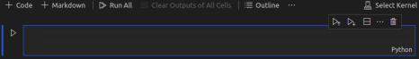
A cell is a container for text to be displayed in the notebook or code to be executed by the notebook’s kernel.
Additionally, the kernel is the computational engine that executes the code contained in the notebook document.
The kernel can be selected or changed using the Select Kernel section, as shown in the image on the right, where multiple options are available, allowing you to choose your preferred version of Python.

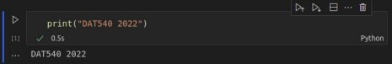
C

Cells form the body of the notebook. In the screenshot above, the blue-marked section is the code cell. There are two types of cells that we will cover and use regularly.
The code cell is the section where we write and execute code. When the code is executed, the result is displayed below the cell.
You can add a code cell using Esc + A (to add above) or Esc + B (to add below).
The markdown cell is the section where we write our markdown and execute which outputs the text in Markdown Format.

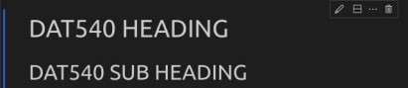

Quick Hints
- Whenever a new notebook is opened, the first cell is always a code cell.
- To run a cell, you can click the play button to the left of the cell or press Ctrl + Enter.
- The + Code button adds a new code cell to the notebook. Similarly, the + Markdown button adds a new markdown cell.
- The Run All button executes every cell in the notebook from beginning to end. If an error is encountered, execution stops, and the error is displayed directly below the cell where it occurred.
- The Clear Output of all Cells button clears the output of all cells, leaving a clean code and markdown format.
- The Restart button restarts the kernel, which is useful if you encounter kernel crashes or other issues.

Quick Guide: Google Colab (Alternative)

An active Google Account required

Setup
To use Colab open https://colab.research.google.com/.

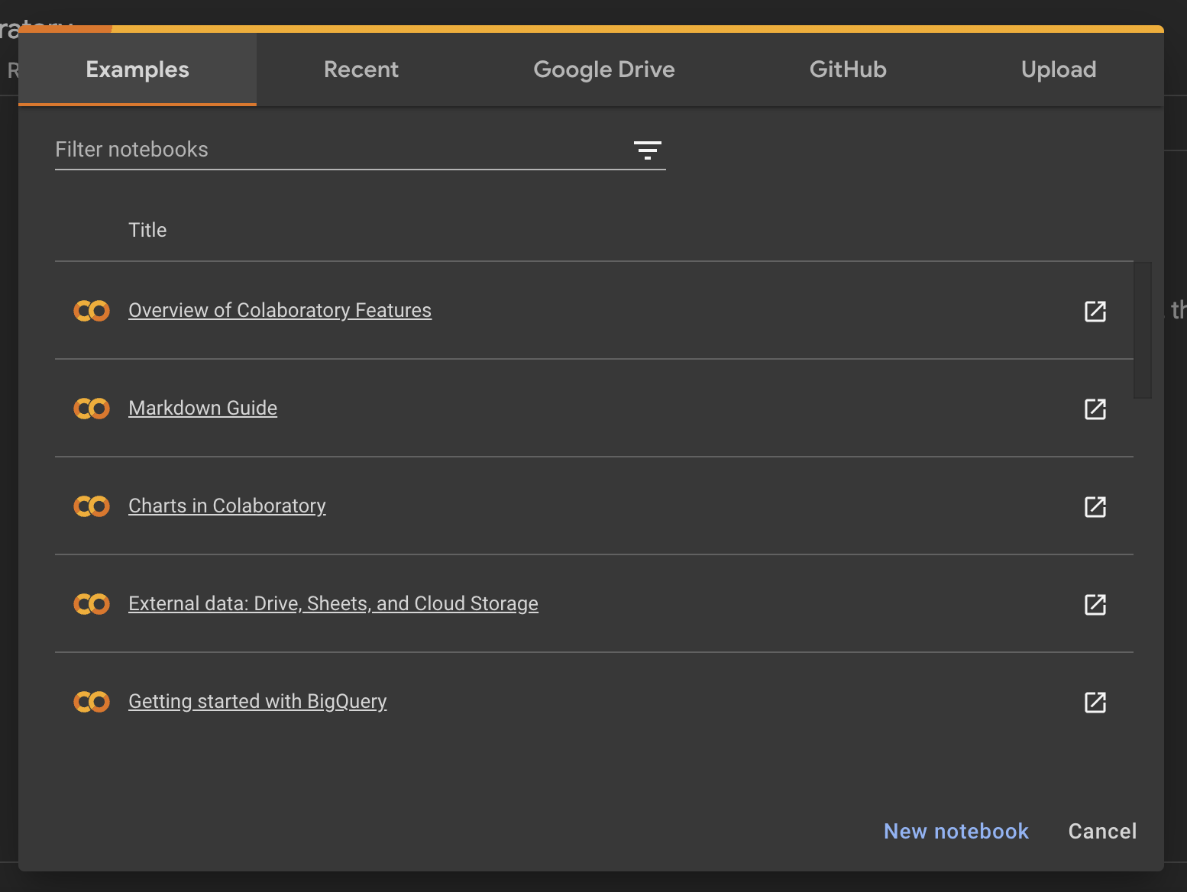

Once you are logged in you should see a greeting page with the option to open Example notebooks, view your recent ones, browse your Google Drive, connect to GitHub, or upload a Notebook.
For this guide, you will want to create a new notebook by clicking the according button on the bottom right.

When completing the labs you will use the Upload function.

Using Colab Notebooks

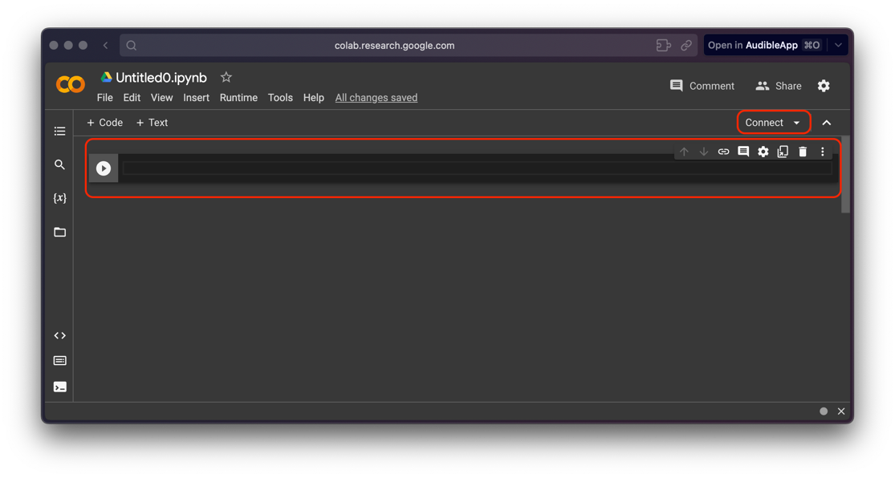
After creating a new notebook you should see something like in the image above. Similar to Jupyter Notebooks in VS Code you will be greeted by an empty Code Cell.

A cell is a container for text to be displayed in the notebook or code to be executed by the notebook’s runtime.

A runtime, in this context, refers to an isolated environment where you can execute code and run programs. It's essentially a virtual machine that provides the necessary resources for your code to run.

A hardware accelerator is a specialized hardware component designed to speed up specific types of computations. Examples of hardware accelerators include GPUs (Graphics Processing Units) and TPUs (Tensor Processing Units).

When you hit the “play” on a code cell or the “connect” button on the top right, Colab will automatically connect you to a standard Python CPU runtime.
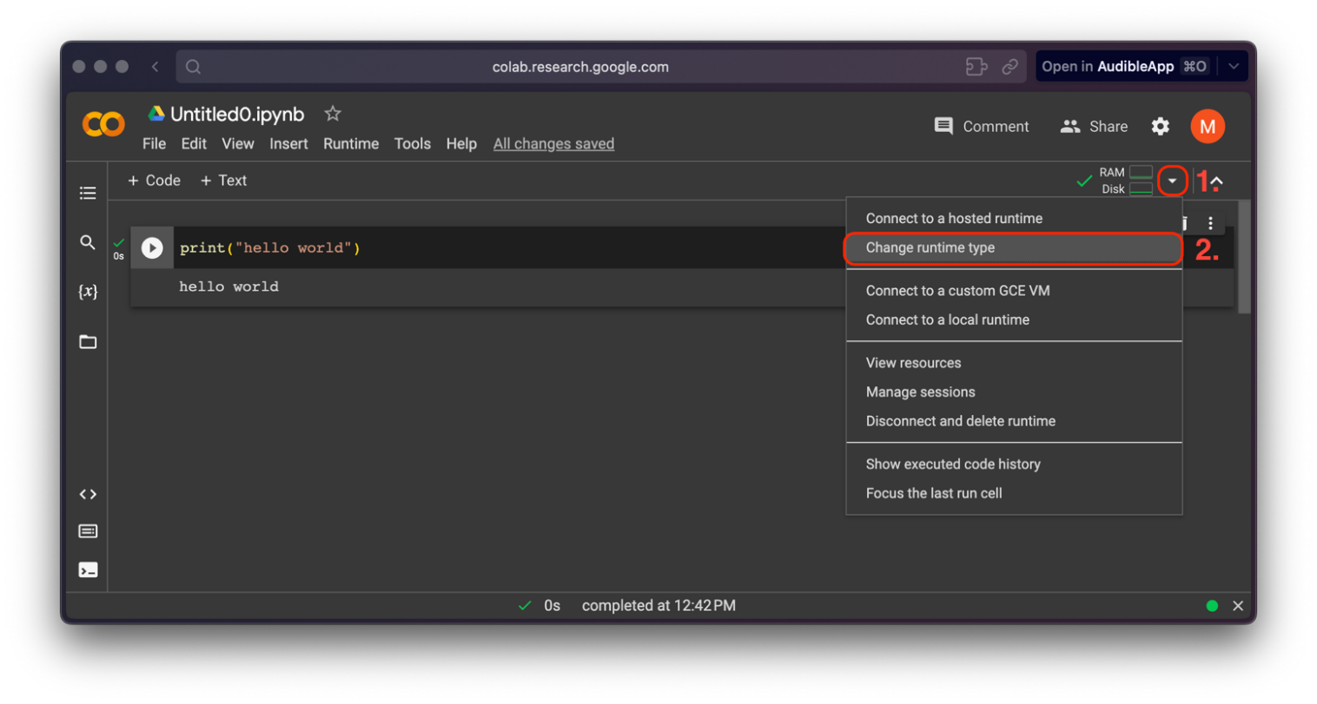
To connect to a more powerful runtime, first, click on the dropdown next to the small recourse display and then on “Change runtime type”.

Here you will have the option to connect to a GPU or TPU hardware accelerator which can help improve your runtime depending on your task:

- GPU (Graphics Processing Unit): Originally designed for rendering graphics in video games, GPUs have highly parallel architectures that make them suitable for accelerating many types of computational tasks, including deep learning.

- TPU (Tensor Processing Unit): Developed by Google specifically for machine learning tasks, TPUs are optimized for tensor operations commonly used in neural networks. They are designed to provide high-speed training and inference for AI models.
In addition to code cells, you can also add Markdown cells. Markdown is a lightweight markup language that allows you to create formatted documents without the need for complex HTML or formatting codes. Markdown cells are particularly useful for adding explanations, documentation, annotations, or even creating entire reports alongside your code.
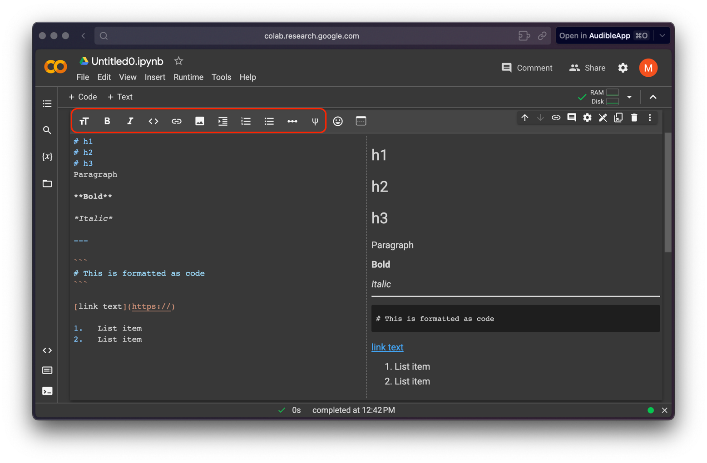
In a Markdown cell, you can include:

- Text: You can write plain text, headings, paragraphs, and lists (both ordered and unordered), and emphasize text using formatting like bold or italics.

- Links: You can create clickable links to websites or other documents.

- Images: You can embed images by providing the image URL.

- Headers: You can create headings of different levels using the # symbol.

- Code Blocks: You can include code blocks by wrapping the code in triple backticks. This is useful for showing code examples without actually executing them.

- Tables: You can create simple tables with columns and rows.

- LaTeX Equations: If supported, you can include mathematical equations using LaTeX syntax.

- Horizontal Rules: You can add horizontal lines to separate sections.

Quick tips for colab

Some useful shortcuts:

Shift + Enter: Jump to the next cell and execute the current one.
- Ctrl + F9: Run all cells
- Ctrl + P: Print the notebook (select “save as PDF to export the notebook”)

Code Execution Order:
- The order in which you execute cells matters. Make sure to run cells in the correct order, especially when cells depend on variables defined in earlier cells.
- You can move existing cells by using the small arrow buttons at the top right corner of a cell

Shell Commands:
- Prefix a code cell with an exclamation mark to execute shell commands. For example, !ls will list the files in the current directory.
- You can install external libraries using !pip install directly in a code cell. Specify versions if needed to ensure compatibility.

Collaboration:
- You can share Colab notebooks with collaborators, allowing them to view and even edit the notebook simultaneously. Share notebooks using the "Share" button in the top-right corner.

Keep in mind that Colab has certain limitations on resources (runtime duration, GPU/TPU availability, memory), and notebooks may occasionally disconnect due to inactivity or other reasons. Colab Pro (a paid version has higher resources).

